*SIMPLE 2D CAD APPLICATION* Product Design Specification

Team: Insignia Version *<1.0>*

*02/11/2001*

Team Members:

1. MANAN SETHI
2. TASHU CHUGH
3. TANYA GOYAL
4. Abhijeet Singh HADA
5. SHIVAM TYAGI

**TABLE OF CONTENTS**

1. **INTRODUCTION**
   1. PURPOSE OF THE PRODUCT DESIGN SPECIFICATION DOCUMENT
   2. PROBLEM DEFINITION AND SOLUTION
2. **GENERAL OVERVIEW AND DESIGN GUIDELINES/ APPORACH**

**2.1** ASSUMPTIONS / CONSTRAINTS / STANDARDS

1. **FUNCTIONAL SPECIFICATION**
   1. FEATURES
   2. PERFORMANCE
   3. HARDWARE REQUIREMENTS
2. **EXTERNAL USER INTERFACE**
   1. USE-CASES
   2. APPLICATION PROGRAM INTERFACES
   3. USER INTERFACE DESIGN
3. **TECHNICAL SPECIFICATION**
   1. SYSTEM ARCHITECTURE
4. **REFERENCES**
5. **INTRODUCTION**
   1. PURPOSE OF THE PRODUCT DESIGN SPECIFICATION DOCUMENT

Our Product Design Specification document documents and tracks the necessary information required to effectively define architecture and system design in order to give the development team guidance on architecture of the system to be developed. The Product Design Specification document is created during the Planning Phase of the project. Its intended audience is the project manager, project team, and development team. Some portions of this document such as the user interface (UI) may on occasion be shared with the client/user, and other stakeholder whose input/approval into the UI is needed.

* 1. PROBLEM DEFINITION AND SOLUTION

2D CAD can be used across a wide range of industries such as automotive, aerospace, fashion and industrial design. Helps increase productivity of a designer. It is used to design Curves and figures in two-dimensional and is used for accurate creation of photo simulations.

1. **GENERAL OVERVIEW AND DESIGN APPROACH**
   1. ASSUMPTIONS / CONSTRAINTS / STANDARDS
2. **FUNCTIONAL SPECIFICATION**
   1. FEATURES
3. Assist with the design’s creation, modification, analysis, or optimization of a design.
4. Handling objects such as shapes (for now, circles, quadrilaterals and lines) and layout for different applications.
5. Designs can be copied and pasted easily from
6. Drafting views such as planes, sections, and elevations, designers can visualize completed design and make any amendments as needed.
7. Software is much faster than manual drawing methods, it also allows designers to explore different design options more efficiently.
8. Being able to insert commonly use components into a drawing greatly speeds up the drawing process while also removing the potential for errors.
   1. SYSTEM REQUIREMENTS:

**Operating System:** - Window XP of higher with latest updates installed

**Processor**: - 500Mhz or more

**Ram**: - 128 MB or more

**Graphic** **Card**: - At least 64 Mb or more

* 1. PERFORMANCE

1. **EXTERNAL USER INTERFACE**
   1. USER INTERFACE DESIGN

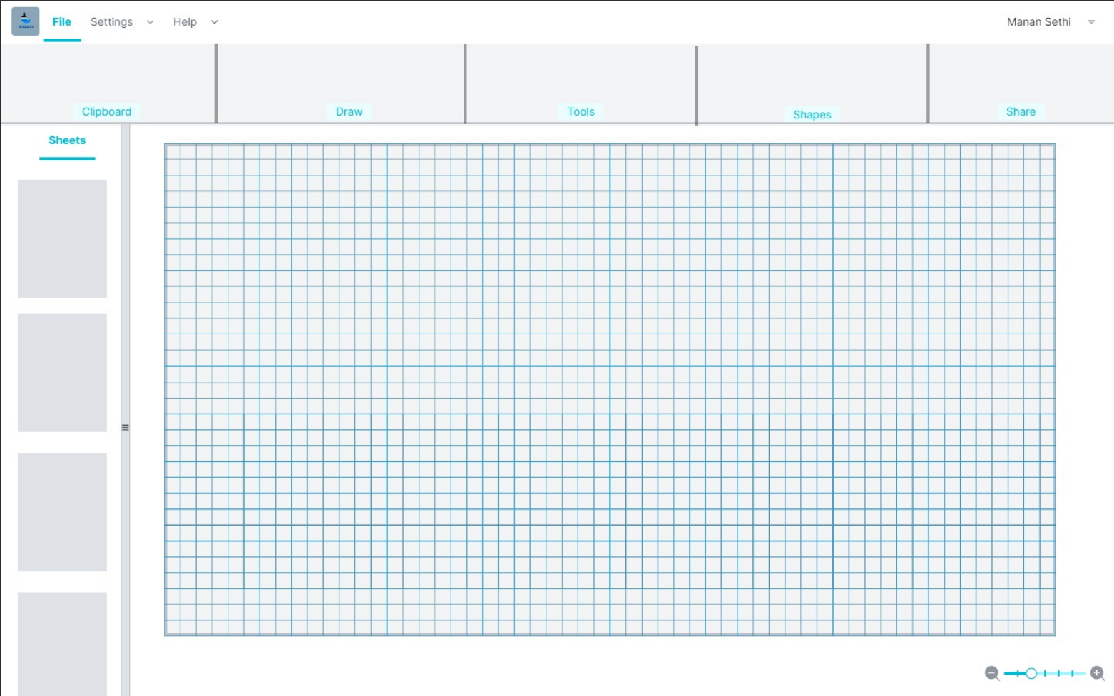

1. **TECHNICAL SPECIFICATION**